

Community Learning Assignment

‘Man Up’: Masculinities and Mental Health Help-Seeking Behaviors



Special Topics in Sociology

# Event Summary

This online event was a panel discussion by the World Health Organization (WHO) Regional Office for Europe. The panel included Professor Brenden Goff who is a professor of social psychology, Isabell Yodi who is the program manager for gender and health and human rights at the WHO office in Copenhagen, and John-Carlos Galleoni who has been campaigning for mental health awareness since 2012. They came together to discuss “masculinities, [which are] socially constructed ideas of what it is to be a man” ('Man Up': Masculinities and mental health help-seeking behaviours, 2019). They also discuss the high level of suicide in men across the world and some of the barriers that men may have when seeking mental health support. The goal was to open up a discussion on what can be done to help reach men seeking mental health support as well as troubleshoot more solutions for men with mental health issues (rather than just prescribing sleeping pills, for example). They briefly discussed some gender-specific mental health strategies that the WHO has written reports on to help in response to the high suicide rate in men. They mentioned that one of the leading concerns regarding men seeking mental health support is the lack of knowledge about supports available, which can often lead to a lack of understanding of what needs are not being met. Also, with the idea of masculinities, which can often be tied with being strong or never asking for help, how do we overcome this obstacle as a society so that men can feel comfortable seeking help before it is too late. One of the panellists, John-Carlos, said that “89 men commit suicide every week” and an audience member mentioned that “the rate at which someone kills themselves anywhere in the world is every 40 seconds” ('Man Up': Masculinities and mental health help-seeking behaviours, 2019). This is a serious problem; they mention that they have been doing lots of research on the topics of mental health and if they are not implementing their solutions then they aren’t doing their intended job.

## Event Date

September 9th 2019

## Contact Information

Video Website: <https://www.youtube.com/watch?v=w3sVcvLmlX8&feature=youtu.be>

# Connection to Society

“The suicide rate in men is twice the size of that in women, and women are twice as likely to be diagnosed with depression than men” ('Man Up': Masculinities and mental health help-seeking behaviours, 2019).

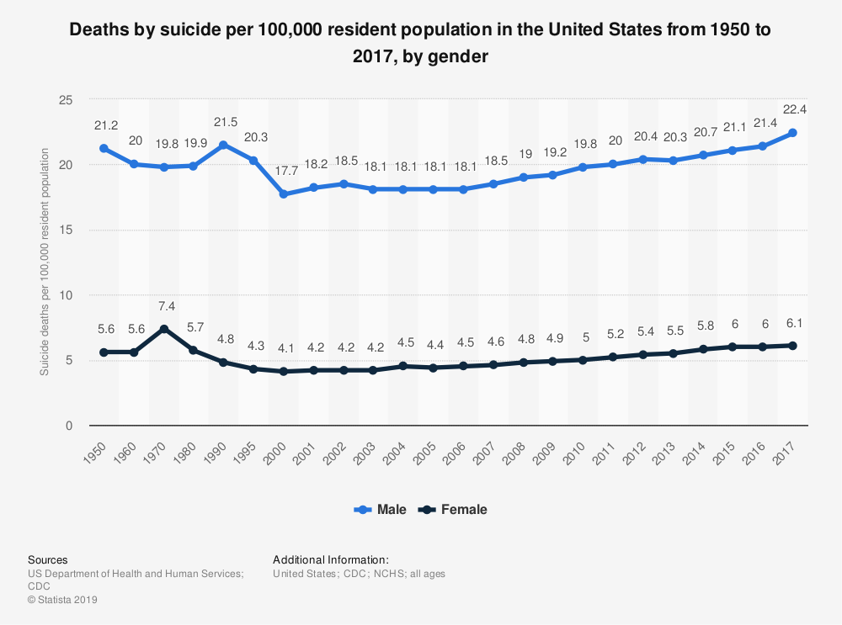

Figure 1: Suicide Death Rate U.S. by Gender 1950-1970, Statista

This leads to the thought that men are either delaying seeking help or often do not seek help at all. This is in part due to the prescribed definition of what it means to be a man; often the idea of being strong and not asking for help being some of the ‘masculinities’ that play a big part in what most people view as an integral part of being a man. Though it is mentioned during the event that “masculinities are a more complex and fluid set of elements that operate differently in different scenarios along with giving the idea that men should or should not behave in different ways,” most people are not aware of the different aspects of masculinities and have a very strict definition of masculinity as well as gender which “has a negative impact on men who live in areas where this concept is very prevalent” ('Man Up': Masculinities and mental health help-seeking behaviours, 2019). “Masculinities are not inherently negative some aspects, however, harm the mental health of men or hurt the ability for men to reach out for support, especially sexual minority men” ('Man Up': Masculinities and mental health help-seeking behaviours, 2019).

Many men have been or will be “subject to **homophobia** from a very young age, this creates mistrust” as well as the feeling of being alone which contribute to mental health problems later in life ('Man Up': Masculinities and mental health help-seeking behaviours, 2019). This also can contribute to homosexual and bisexual men not feeling comfortable to speak with either friends, family, doctors, or therapists about any mental health issues they may be having. This often leaves a feeling of helplessness and many will not attempt to seek any mental health support. This helps to explain the large difference in suicide attempts between gay and bisexual men when compared to heterosexual men.

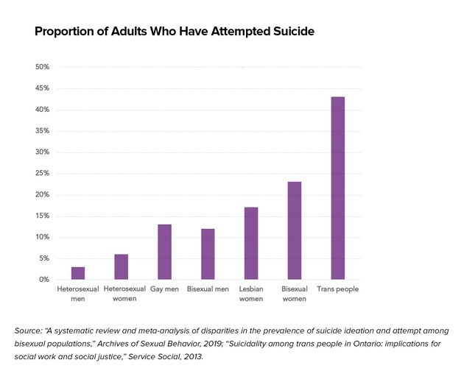

Figure 2: Proportion of Adults Who Have Attempted Suicide, HuffPost

This ‘man-up’ culture we are currently living in has made is so that “men do not seek mental health solutions either formally or informally” ('Man Up': Masculinities and mental health help-seeking behaviours, 2019). “There is a stigma of mental health in many countries generally, which is multiplied for men because of the stigma created by masculinity pressures” ('Man Up': Masculinities and mental health help-seeking behaviours, 2019). We as a society need to help change or morph our definition of masculinities to encompass and encourage men to be vulnerable and to ask for help either from friends and family or seeking help through a more formal route.

# Connection to Special Topics in Sociology

This event and its topic relate most with *Conflict Theory*, which focuses on the conflict between social groups, as well as **gender-conflict theory** which focuses on **inequality** based on gender. The event goes into detail about the idea of masculinities and **heteronormativity**, which is the idea that traditional gender roles as well as **sexuality** are ideal in society. I believe that this topic is also closely related to the conflict between **gender roles** in society. Embedded in all of these concepts are the traditional **gender roles** for men and women, which includes the concepts of masculinities and femininities. This is the basis for the event topic, which expands on how this toxic ‘man-up’ culture contributes to the lack of mental health support given to men in society. Women are often given many different channels for ways to cope with mental health, for example, talking with friends and family about emotions and stress in their life as well as therapy. Often hairdressers are also given training on how to listen empathetically which caters more to women because generally they will get their hair done more often and spend more time there enabling them the opportunity to open up about their life. However, often when men try to open up to friends or family about their emotions, they are given some form of ‘man-up’ rather than an empathetic ear. It is important not to perpetuate these masculine **stereotypes** in society that men aren’t allowed or suppose to have emotions or that they should not be opening up about them.

# Reflection

I was very surprised to learn that the suicide rate is double that of women and that women are twice as likely to be diagnosed for depression. It was shocking to learn that women are more likely to seek help because they know where to look for support and because they already have so many avenues currently in place for women to discuss any mental health issues. I remember when I was young, I did try to influence my younger brother to ‘man-up’ and to be less emotional because I was concerned about him getting teased in school for being emotional. At the time I had no idea about these societal gender norms that were in place, I just knew that it wasn’t ‘normal’ for men or boys to be emotional. Going forward a few years I have been encouraging my guy friends to open up about their personal life as well as their emotions, letting them know that its normal to talk about their emotions with people. It's strange to think how much my perspective has changed over the years and I hope that society continues to grow and open up the perspective of masculinities and femininities to a more gender-neutral way of looking at emotions as well as mental health. Also, I found it surprising how few mental health services we currently have in place are directed towards men, as well as most being directed towards women rather than gender-neutral places. This can be so discouraging to men looking for support and I think that its something that we need to focus on as a society.

I thought it was interesting how they mentioned some avenues that they could use to encourage men to be more vulnerable or to seek support including leadership and role models, using films as well as current channels that engage men to help teach some of the tools available to them as well as strategies that they can use. I think that this needs to be encouraged in our society and that there needs to be more drive and direction from local governments to help implement more gender-neutral forms of mental health support as well as a broader definition of masculinities and felinities and that the idea of these terms does not necessarily have to be defined by gender and/ or sexuality.

# References

*'Man Up': Masculinities and mental health help-seeking behaviours*. (2019, September 9). Retrieved from YouTube: https://www.youtube.com/watch?v=w3sVcvLmlX8&feature=youtu.be